Steps I take to Use An Inline Image on Adept Play
This is what I do.
Step 1: Get the Image URL
- Search for an image
- Go to that site
- Right Click On the Image and open in a new tab
- Right Click on the Image in the new tab to get the image URL
Step 2: Put the Image in Your Post
- Open A New Post
- Click on the Universal Image Button
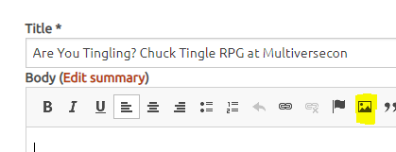
- Put in the URL
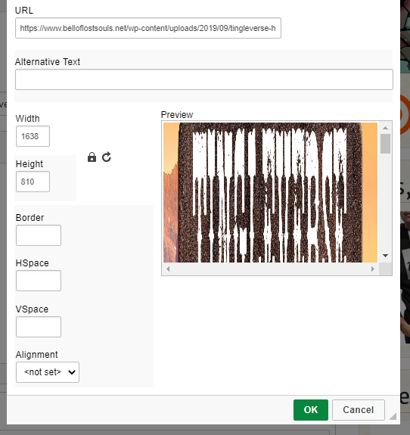
- See where the width and height are? Whichever number is largest, I reduce that to about 400 or 300 as requested. The other number will automatically change with it. Note, if this is still showing the image squished, I would just reduce it again, down
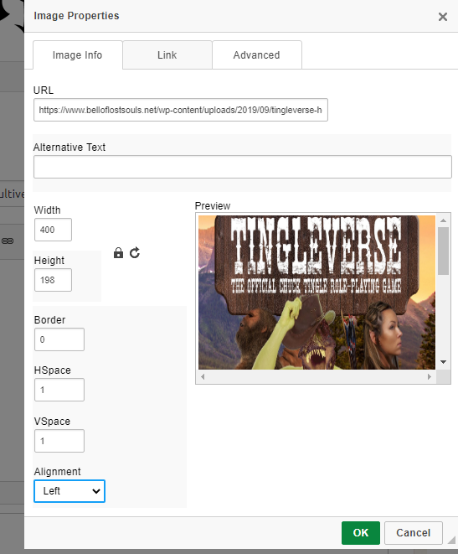

- Border = 0 is best practice. Alignment = Left. I give an HSpace and VSpace of 1 or 2 (I actually did got to 2 in the post) to provide space between the image and the text.
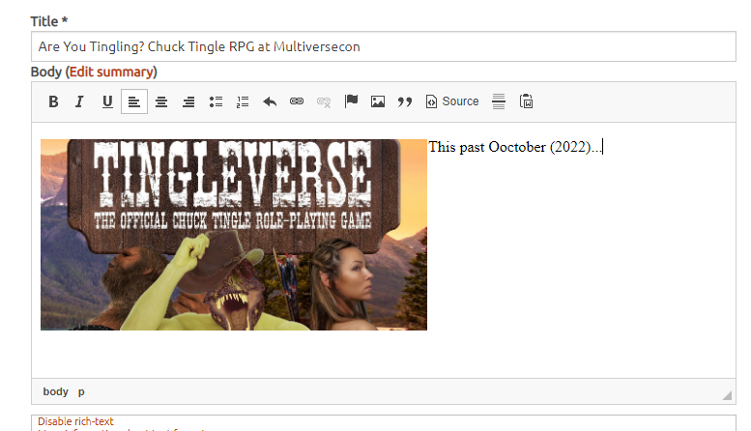
This is the end result. Pretty simple and just takes a little practice.

